Deprecated Functions
Triage Procedure

Revision
Version 2
4/17/26 12:42 PM

SME
Charles Wilson

Abstract
This document describes the procedure used to perform the triage activity described in the AVCDL ^{[1]} secondary document Currently Used Deprecated Functions Document ^{[2]}.

Group / Owner
Security / Security Architect

Motivation
This document is motivated by the need to track use of deprecated (unsafe) functions within safety-critical, cyber-physical systems.
Note: Within the context of this document, the terms security and cybersecurity are used interchangeably. It is presumed that the term security is being used in reference to cybersecurity and not physical security.

License
This work was created by Torc Robotics and is licensed under the Creative Commons Attribution-Share Alike (CC BY-SA-4.0) License.
https://creativecommons.org/licenses/by/4.0/legalcode

Audience
The audience of this document is the cybersecurity practitioner who will be handling deprecated function reporting.

Completeness of Output
Since deprecated function scanning is an as-is analysis, it is critical to ensure that the information gathered is as accurate and complete as possible. As with any cybersecurity assessment, it is not the place of the cybersecurity SME to make assumptions on the part of engineering. All information should be sourced from and confirmed by the owner of the element under consideration.

Disposition of Output
Once completed, the generated output (Currently Unused Deprecated Functions Report) should be managed in the organization’s document management system (DMS) as a document of record.

Entry Criteria
This document assumes that the reader understands the purpose of deprecated function tracking and replacement. Further, that the reader has read and understood the Currently Used Deprecated Functions Document AVCDL secondary document.

Prerequisites – Development SME

Qualifications
It is required that the development SME is both a qualified and trained development SME with expertise in the element under consideration.
Note: The specific qualifications and training of development SMEs necessary to assert expertise in providing accurate information regarding the element under consideration is outside the scope of this document.
Note: The development group is responsible for determining and making available the appropriate SME for the analysis of the element under consideration.

Knowledge
It is required that the development SME have expertise in the element under consideration in the context of the tool which generated the cybersecurity issues under review.

Prerequisites – Security SME

Qualifications
It is required that the security SME is both a qualified and trained security architect (shown above on title page as Owner) as defined by the NIST NCWF role SP-ARC-002 and detailed in the NCWF Roles - Security Architect section of the AVCDL Background Material elaboration document.

Knowledge
It is required that the cybersecurity SME understands the purpose of deprecated function tracking and replacement.

Background Information
It is required that the cybersecurity SME has read and understands the Currently Used Deprecated Functions Document AVCDL secondary document. Additionally, that the cybersecurity SME has taken training relevant to this activity.

Prerequisites – Input Materials
It is required that the cybersecurity SME acquire all relevant documentation related to the element under consideration necessary to complete the procedure.
It is required that the development group provide all relevant documentation related to the element under consideration necessary to complete the procedure.

Triage Activity
The workflow diagram for the triage activity of the Deprecated Functions process is shown below.
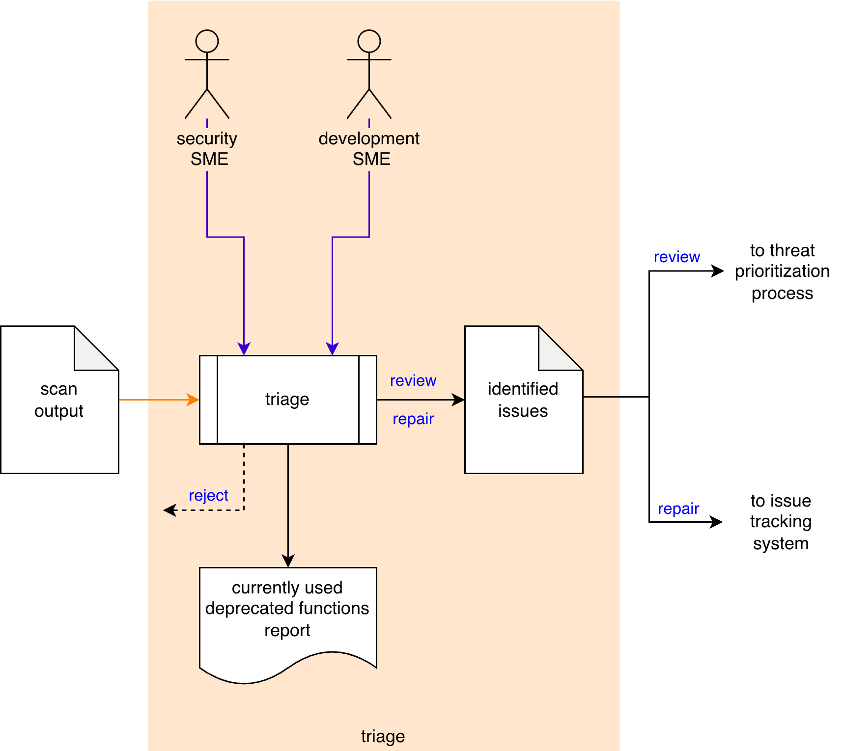
The Security SME and the Development SME review the Scan Output generated in the deprecated function scan activity ^{[3]} to identify deprecated function use needing further investigation. These Identified Issues are sent to the threat prioritization process ^{[5]}. A Currently Used Deprecated Functions Report is be generated.
Note: Depending on the nature of an identified issue, it may be entered directly into the issue tracking system.
Note: The recommended form of the Identified Issues artifact is JSON-encoded SARIF. This document assumes SARIF version 2.1.0 ^{[4]} or later.

Methodology
The purpose of triage is first and foremost to eliminate those issues which are false positives or out of scope. A secondary goal is to identify “must fix” issues. What remains is put into the threat prioritization process.
There are three options when dispositioning an issue. These are:

Reject
This disposition should be assigned when the issue is determined to be a false positive or out of scope.

False Positive
If it is determined that the function is incorrectly flagged, the tooling should be reviewed and corrected. The analysis should then be re-run to verify that the issue is no longer flagged.

Out of Scope
If the issue is contextually incorrect (out of scope), the tooling should be updated to disable scanning of the beyond the element’s scope. The analysis should then be re-run to verify that the issue is no longer flagged.

Repair
This disposition should be assigned when the issue is clearly one which requires mitigation. These issues should be directly entered into the issue tracking system.

Review
This disposition should be assigned when the issue is determined to be valid but requires additional review via the threat prioritization process.

Deprecated Function Triage Template
The triage activity may be documented using the AVCDL deprecated function triage template Microsoft Excel workbook ^{[6]}.
Note: Other forms of documentation are permissible so long as they provide the information laid out in this document.
There are five sheets in the workbook. They are:
- Cover sheet
- Revision history
- Reference documents
- Triage determination
- Legend
These will be addressed in turn.

Duplication of Rows in the Various Sheets
When there is the need to add rows to the various sheets of the workbook, be sure to duplicate an existing row. This is because validation checks are attached to some of the cells which also enables the use of dropdown lists.

Cover Sheet
The cover sheet of the workbook is shown below:
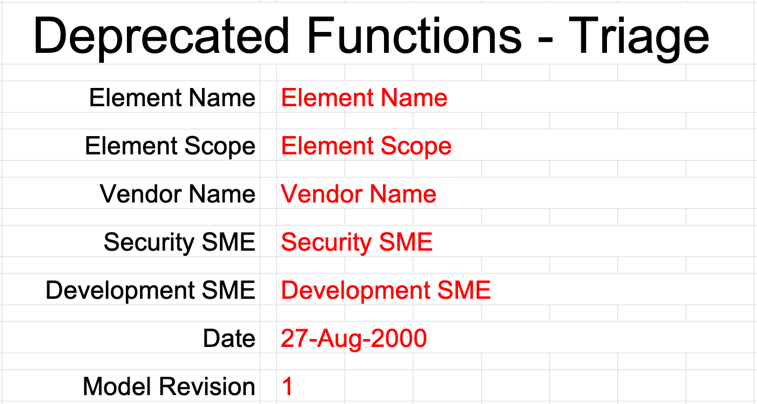
Fields to be completed are shown in red.

Element Name
The element name is the element whose static analysis issues are being triaged.

Element Scope
The scope of the element is left to the discretion of the customer. Examples of element scopes include system, sub-system, component, component software (non-OS), and component OS.
Note: In this context, the customer refers to the entity requiring the activity.

Vendor Name
This is the name of the vendor responsible for the element under consideration.

Security SME
This is the cybersecurity subject matter expert triaging the deprecated function scan output.

Development SME
This is the development subject matter expert providing information about the element.

Date
This is the date when the triage was performed or updated. The date should be updated whenever the document is updated.

Revision
This is the revision number of the document. The revision number is a monotonic and increasing integer, starting at 1. It should be incremented every time the document is updated.

Revision History
The revision history sheet of the workbook is shown below:
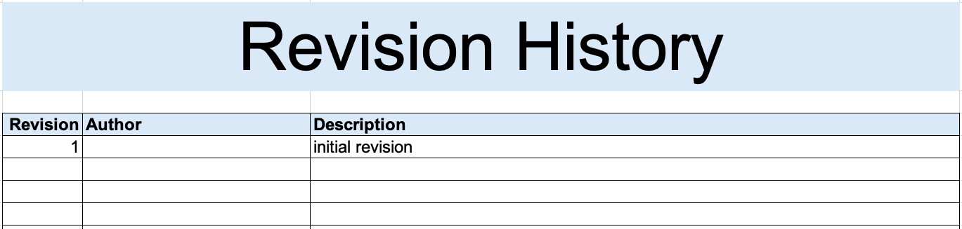

Revision
The revision corresponds to that listed on the cover sheet.

Author
The author corresponds to the security SME listed on the cover sheet.

Description
This is a brief description of changes made to the triage since it was last updated.

Reference Documents
Note: These references are those necessary for the creation of the deprecated function scan output triage.
Note: Reference to the deprecated function scan output should be included.
The references sheet of the workbook is shown below:
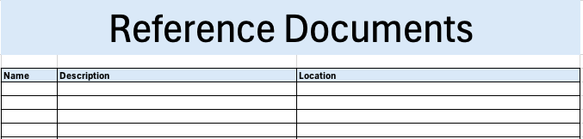

Name
This is the name of the document being referenced.

Description
This is a brief description of the document being referenced.

Location
This is the location of the document being referenced. It may be a physical location or a URL.

Triage Determination
The triage determination sheet of the workbook is shown below:
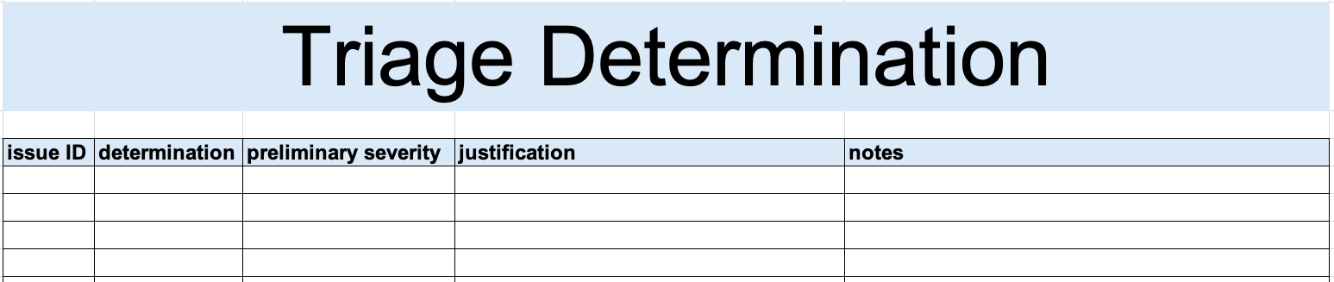

Issue ID
This is the unique issue ID.
Note: When the scan output does not provide a unique ID, an appropriately constructed one should be used in order to provide traceability.

Determination
This is the determination of the issue’s triage. It may be one of the following:
- reject
- review
- repair
Note: The meanings of these were covered earlier in this document.

Preliminary Severity (optional)
If the determination is that the issue is valid, a preliminary severity (rank / likelihood) may be provided.
Note: The preliminary severity value set is not provided as it is highly specific to the organizational and domain. A discussion of quantized rank values can be found in the Ranked / Risked Threat Report ^{[7]} ACVDL secondary document.

Justification
This is the justification for the selected determination. It may be one of the following:
- out of scope
- false positive
Note: If the determination is that the issue is reject, a justification is required.

Notes
This is a general notes field.

Legend
The legend sheet of the workbook is shown below:
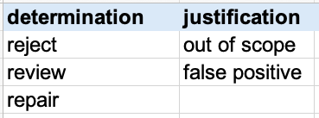
The legend sheet information is used to make the completion of the document easier by providing dropdown lists for common values. It also ensures that spelling errors do not creep into the generated material.
Note: The legend sheet should not be edited. If an unlisted value is required, the template should be separately revised.

Currently Used Deprecated Functions Report
The Currently Used Deprecated Functions Report is the human-readable record of the activity. It is intended to be a standalone document for audit purposes. It’s preferred embodiment for storage in the DMS is PDF. The content of the report is covered in the Currently Used Deprecated Functions Document, AVCDL secondary document.
Note: If possible, it is recommended that the report be generated programmatically. Creating the report from the JSON-encoded SARIF for the Identified Issues file makes this process much easier.
Note: Although all issues contained in the Scan Output may be included in the report, it is recommended to restrict the report to only those items which are not rejected. Additionally, it is recommended that the items chosen for review and repair be in separate sections.

Exit Criteria
This procedure is considered complete once the Currently Used Deprecated Functions Report has been entered into the organization’s DMS as a document of record.
Note: The processes and procedures for entering documents into the DMS, or the updating thereof, are outside the scope of this document.

References
- AVCDL (AVCDL primary document)
- Currently Used Deprecated Functions Document (AVCDL secondary document)
- Deprecated Functions - Perform Scan Procedure (AVCDL tertiary document)
- Static Analysis Results Interchange Format (SARIF) Version 2.1.0
https://docs.oasis-open.org/sarif/sarif/v2.1.0/os/sarif-v2.1.0-os.pdf
- Threat Prioritization Plan (AVCDL secondary document)
- AVCDL deprecated function triage template (AVCDL template)
- Ranked / Risked Threat Report (AVCDL secondary document)
- AVCDL Background Material (AVCDL elaboration document)

